SIMATS ENGINEERING
ASSESSMENT TOOL 1

COURSE NAME: Ethical Hacking COURSE CODE: ITA14

COURSE OUTCOME COVERED

CO2: Foot printing Tools: Conducting Competitive Intelligence, DNS Zone Transfers, Introduction to Social Engineering: Social Engineering Attacks and Countermeasures. (BT3)

Assessment Tool Weightage: 30%

Duration: 90 min Total Marks: 50

Report Analysis

Questions

- A security analyst performed a network scan on the target 192.168.1.10 using the Nmap tool. The report identified several open ports, including HTTP (80), SSH (22), and MySQL (3306), along with the operating system and service versions. Analyze the report and explain the security risks associated with the identified services. Discuss how an attacker could exploit these services and recommend suitable security measures to protect the target system. (20 Marks)

Commands :
  - nmap scanme.nmap.org
  - nmap -sV scanme.nmap.org
  - sudo nmap -O scanme.nmap.org
  - sudo nmap -A scanme.nmap.org
Observation :
  - The host is alive.
  - HTTP (80) is open.
  - SSH (22) is open.
  - SIP ports 5060 and 5061 are open.
  - Operating system information identified.
Security Recommendations :
  - Keep all software updated.
  - Enable firewall protection.
  - Use strong authentication mechanisms.
  - Perform periodic vulnerability assessments.
  - Conduct regular penetration testing.
Report : 

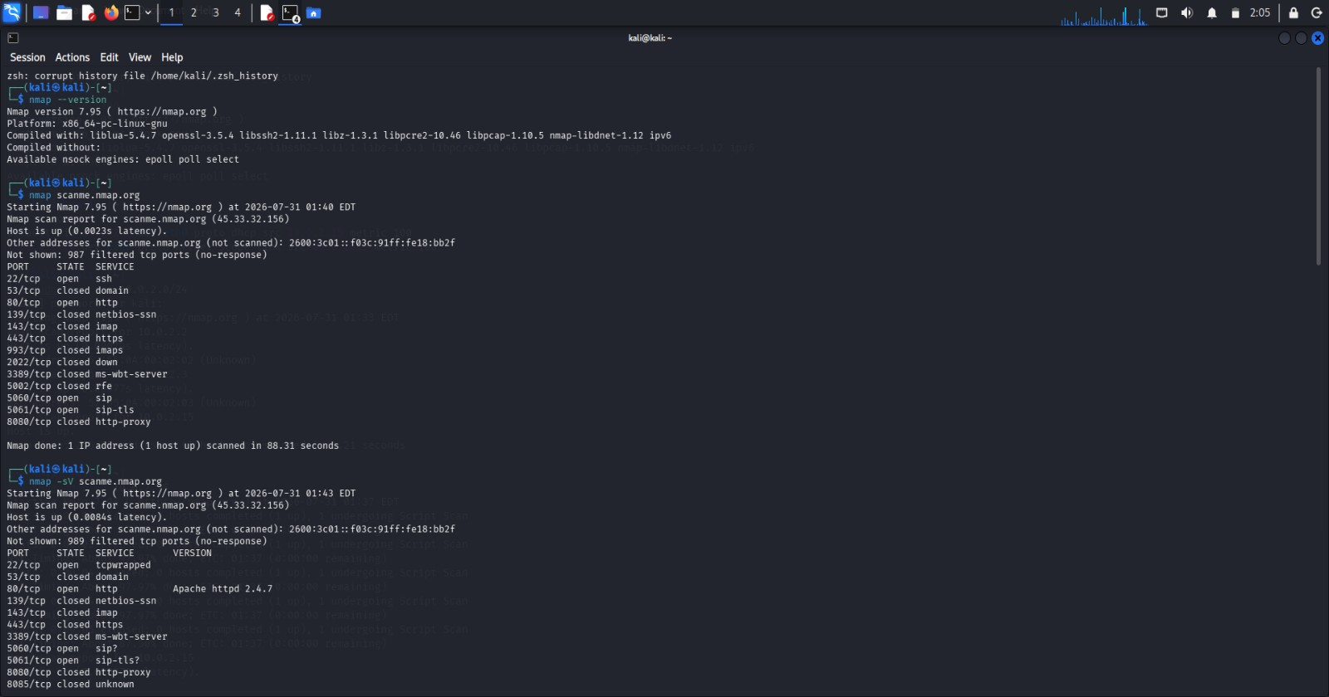
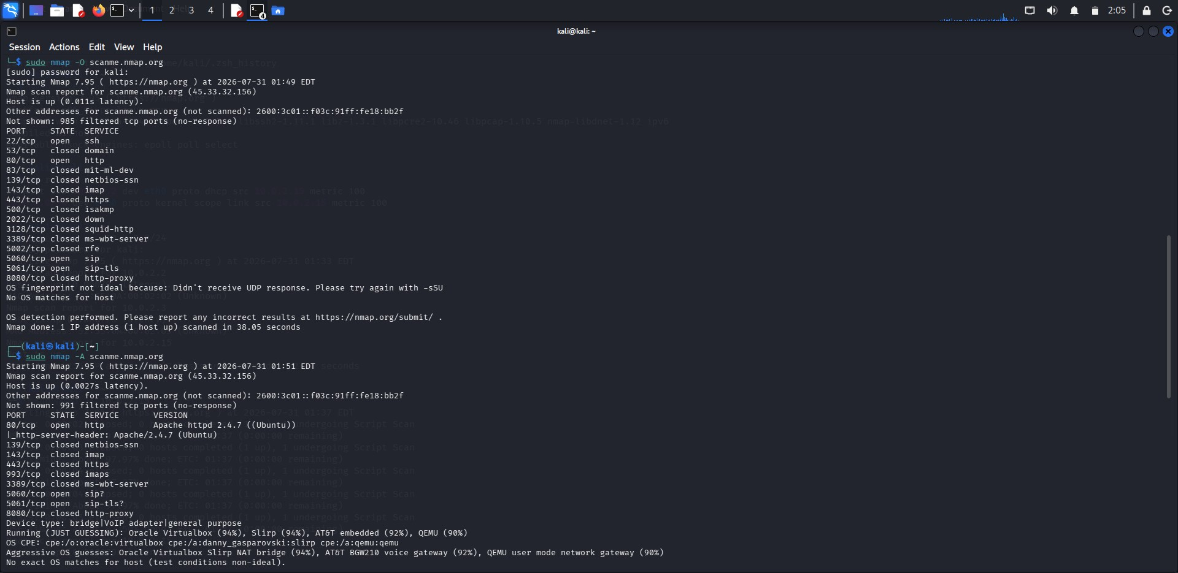

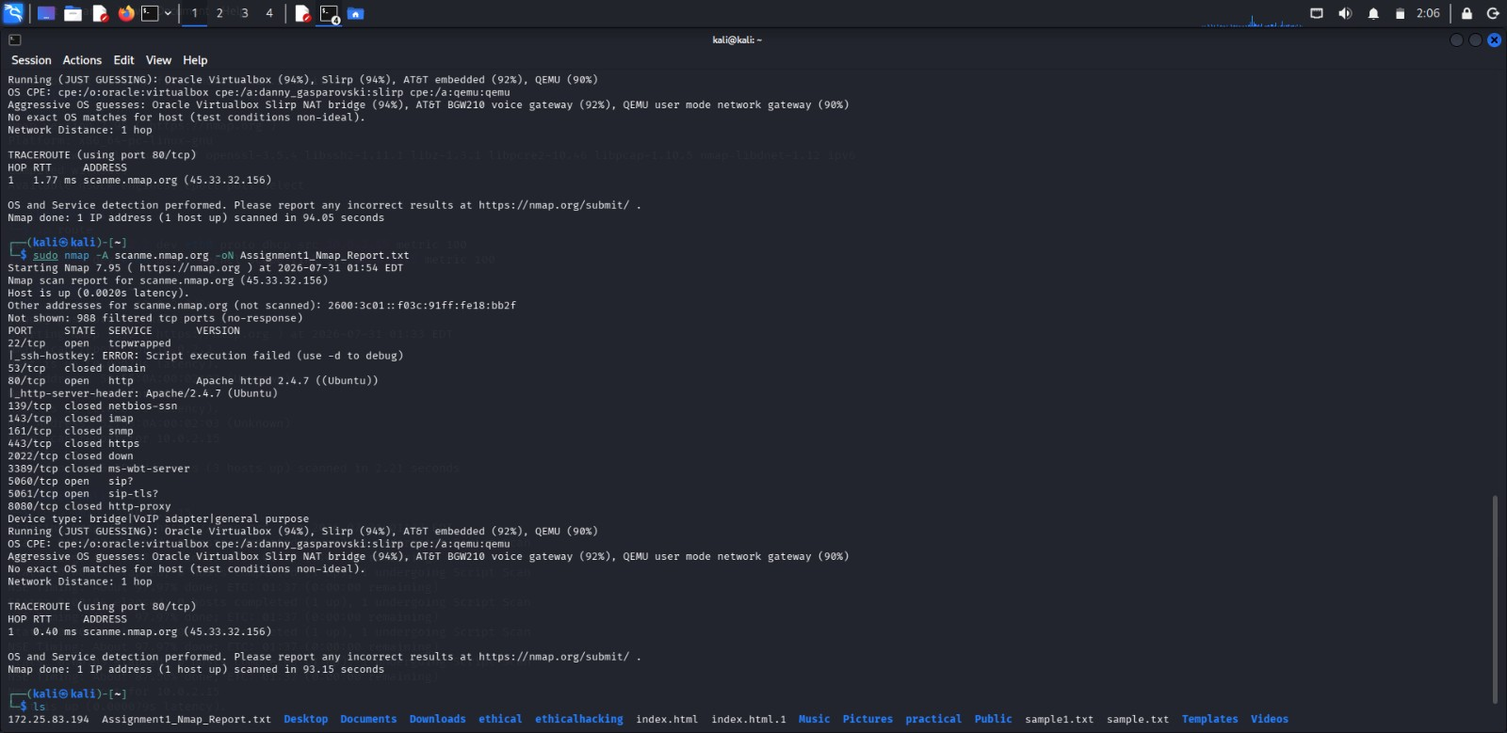

- A phishing awareness campaign was conducted for employees of ABC Technologies Pvt. Ltd. using the GoPhish tool. The report indicates that 40% of employees clicked the phishing link, 20% entered their login credentials, and several users downloaded a malicious attachment. Analyze the report and identify the security weaknesses demonstrated by the employees. Recommend suitable user awareness programs, email security controls, and organizational policies to reduce the risk of successful social engineering attacks.(20 Mark).

Procedure :
  - Created Email Template.
  - Created Landing Page.
  - Configured Mailtrap SMTP.
  - Created User Group.
  - Created Campaign.
  - Send phishing emails.
  - Viewed campaign statistics.
Email Security Controls :
  - Enable Spam Filtering.
  - Use Email Gateways.
  - Configure SPF (Sender Policy Framework).
  - Configure DKIM (DomainKeys Identified Mail).
  - Configure DMARC (Domain-based Message Authentication, Reporting, and Conformance).
  - Block dangerous attachments.
  - Scan email attachments using antivirus software.
  - Enable URL filtering.
Report : 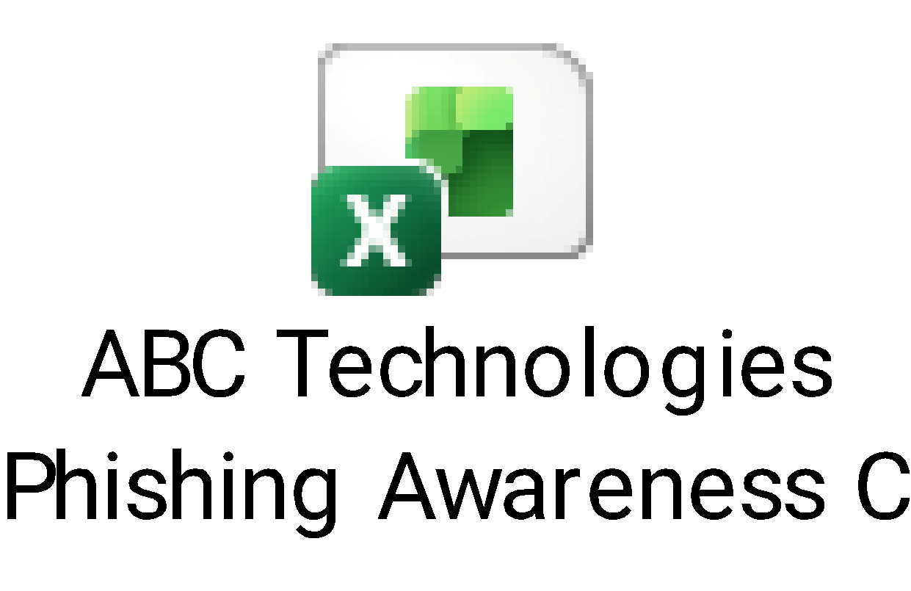

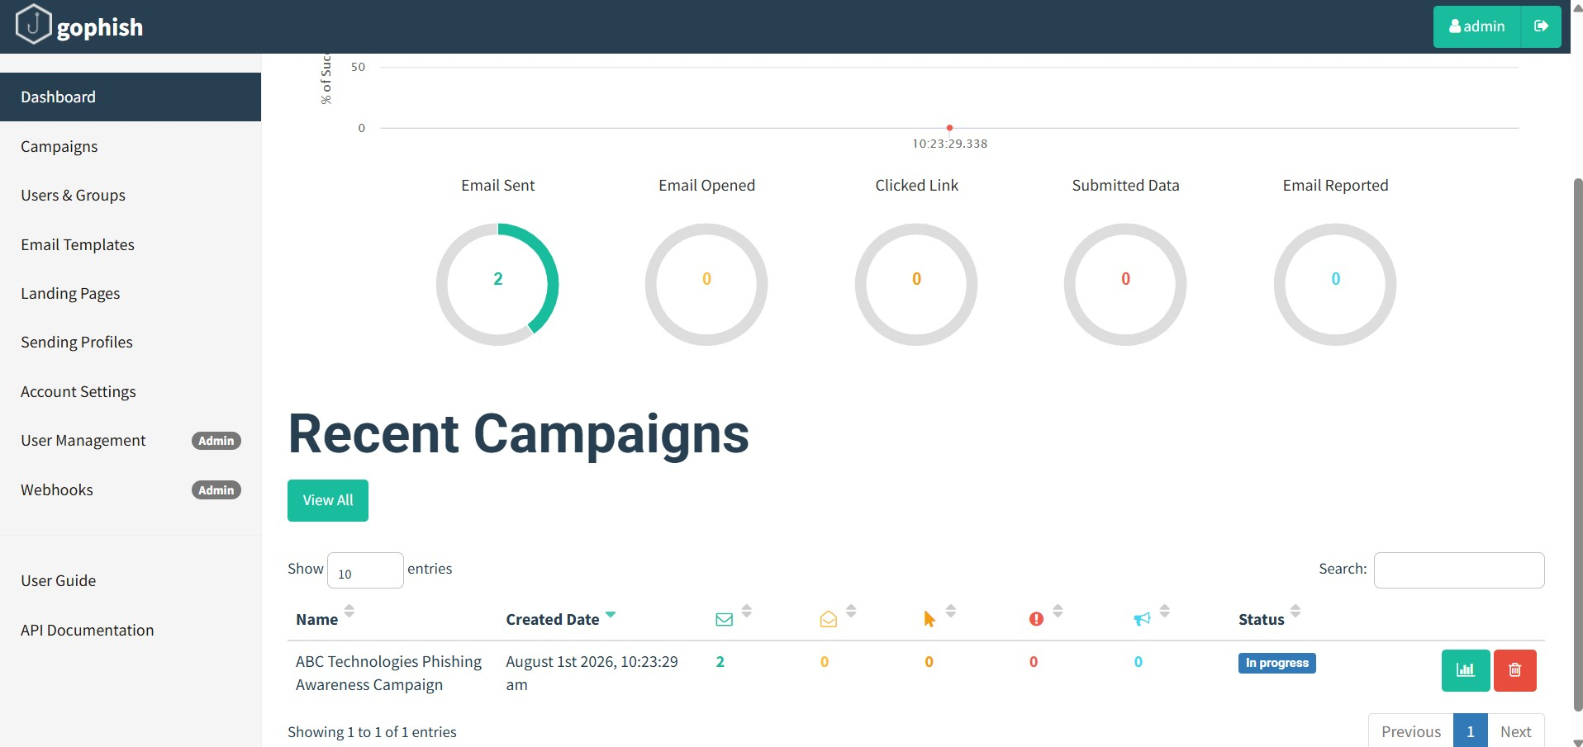

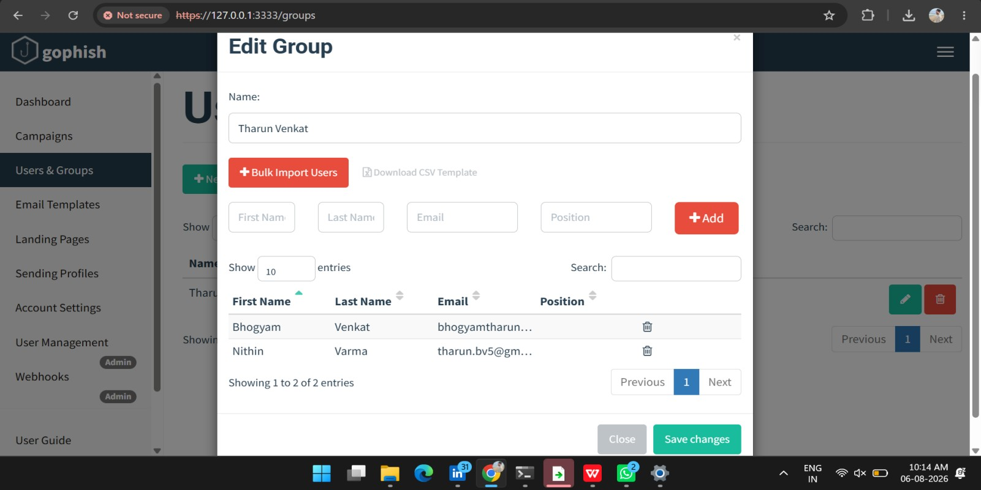

- A DNS assessment report generated using the Dig tool shows that the organization's DNS server permits a successful DNS Zone Transfer (AXFR), exposing internal hostnames, mail servers, and DNS records. Analyze the report and explain the security implications of the exposed information. Discuss how attackers could exploit these findings and recommend best practices to secure the DNS infrastructure..(10 Marks)

Command : dig AXFR zonetransfer.me @nsztm1.digi.ninja
Observation :
  - DNS Zone Transfer succeeded.
  - Internal DNS records were exposed.
  - Mail server records were visible.
  - Multiple hostnames and IP addresses were disclosed.
Possible Attacks :
An attacker can use the exposed information to:
  - Perform reconnaissance.
  - Scan exposed servers.
  - Launch phishing attacks.
  - Target mail servers.
  - Exploit vulnerable web servers.
  - Attempt brute-force attacks on exposed services.
  - Prepare for advanced cyberattacks.
To Secure DNS Infrastructure :
  - Disable DNS Zone Transfer for unauthorized users.
  - Allow AXFR only between trusted DNS servers.
  - Configure Access Control Lists (ACLs).
  - Enable DNSSEC to protect DNS integrity.
  - Regularly update DNS software.
  - Monitor DNS logs.
  - Remove unnecessary DNS records.
  - Perform regular DNS security audits.

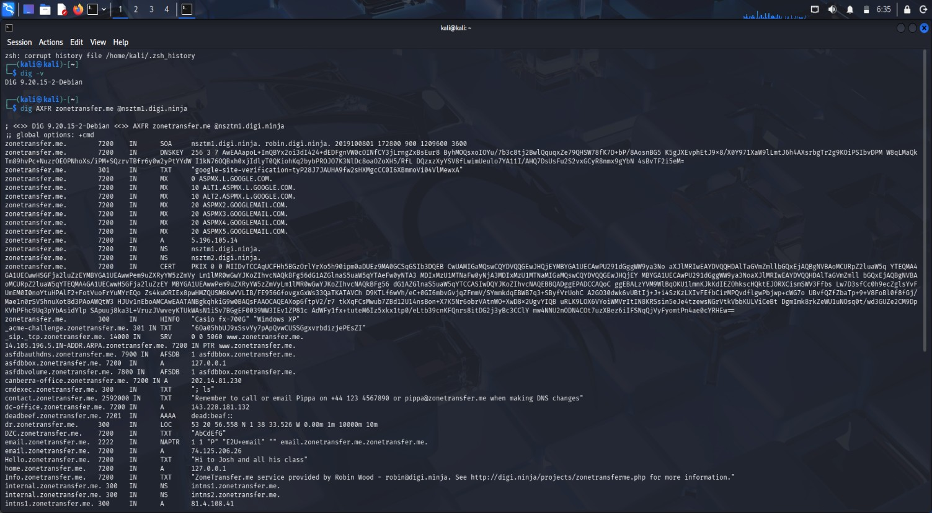

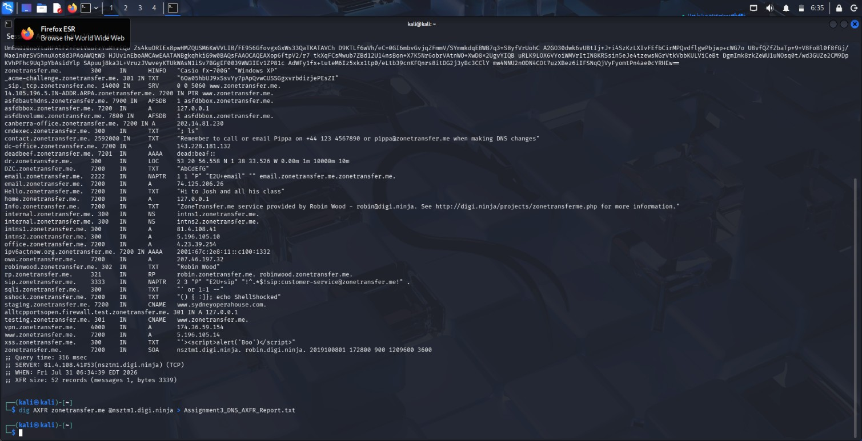

Report :

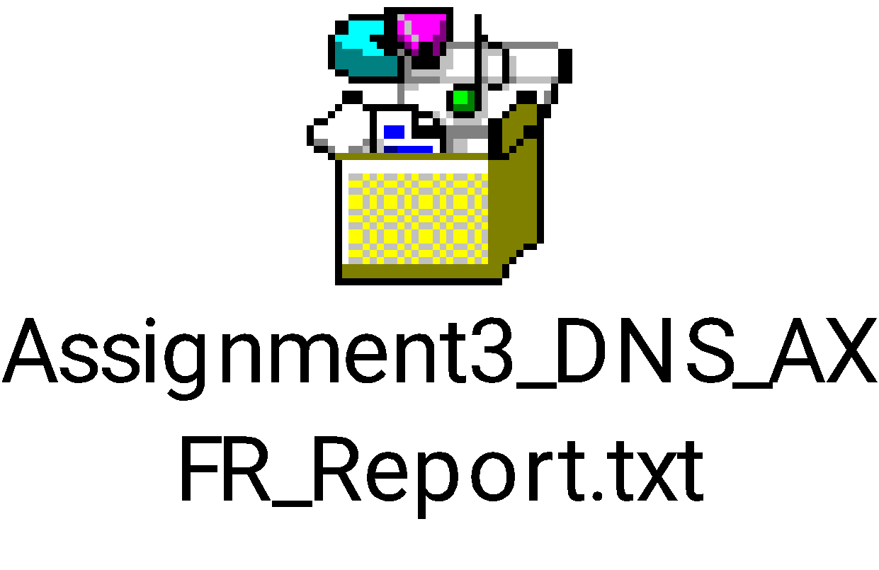

Code of Conduct:

I K.PAVAN (192372008) (Name / Reg No) certify that this submission is my original work and that I have adhered to the guidelines specified for this assessment.
I understand that any violation of academic integrity rules will result in disciplinary action.

K.PAVAN
Signature of the student:

RUBRICS FOR CALCULATION

Report Analysis
Criteria | Weightage (%) | Level 4 (Exemplary) | Level 3 (Proficient) | Level 2 (Developing) | Level 1 (Beginning)
Report Analysis and  Interpretation | 25% | Accurately interprets the  security report,  identifies all key findings, and  explains their  significance with excellent technical understanding. | Correctly interprets most  findings with minor  omissions or inaccuracies. | Identifies only some findings  and provides limited  interpretation. | Unable to interpret the report or  identify key findings.
Identification of Security Risks and  Vulnerabilitie  s | 25% | Correctly identifies all  security risks,  vulnerabilities, and possible  attack vectors with clear technical justification. | Identifies most risks and  vulnerabilities with minor errors. | Identifies only a few risks with limited  technical explanation. | Fails to identify major risks or vulnerabilities.
Application of  Cybersecurity  Concepts and  Countermeas  ures | 30% | Applies appropriate  ethical hacking concepts and recommends  comprehensive, practical, and  technically sound countermeasures. | Recommends suitable  countermeasure s with minor technical gaps. | Provides limited or partially  appropriate  recommendatio  ns. | Recommendati  ons are  inappropriate,  incomplete, or missing.
Technical  Communicati on and  Documentati on | 20% | Response is well-organized, technically  accurate, clearly presented, and  uses appropriate  cybersecurity terminology throughout. | Response is organized and  understandable with minor  documentation or presentation issues. | Response lacks  clarity,  organization, or  contains several technical inaccuracies. | Response is poorly  organized,  incomplete, and difficult to understand.

